APJ ABDUL KALAM TECHNOLOGICAL UNIVERSITY

**College of Engineering Trivandrum Campus**



Thiruvananthapuram - Pin 695 016.

APPLICATION FORMAT FOR STUDENT PROJECT

**SECTION B: TECHNICAL DETAILS**

1. (a) Title of the Project Proposal : Autonomous Tea Harvester (Tea Snapper)
2. Branch / Subject area : Electronics and Communication
3. Project Type (Developmental/Demonstration/Others): Developmental
4. Expected scope/outcome (Tick the relevant one): Product

Product / Prototype / Software / Hardware / Experiment / Publication / Technology / Patent / Innovations

1. **Precise objective (150 words):**

The objective of this project is to develop and implement an autonomous tea harvesting system tailored specifically for the tea plantations of Idukki, Kerala. Leveraging cutting-edge technologies such as the Jetson Nano and Pixhawk flight controller, the system aims to revolutionize traditional tea harvesting methods by introducing automation, precision, and efficiency. By integrating AI capabilities for leaf detection, disease recognition, and path planning, the system seeks to optimize harvesting operations while reducing labor requirements and costs. Additionally, the system prioritizes safety measures and real-time monitoring to ensure the safety and efficiency of operations in the challenging terrain of Idukki's tea estates. Ultimately, the project aims to enhance the quality, productivity, and sustainability of tea cultivation in Idukki, contributing to the region's economic growth and preserving its rich cultural heritage.

**Abstract (400 words):**

The tea plantations of Idukki, nestled in the picturesque landscapes of Kerala, India, represent a vital sector of the region's economy and cultural heritage. With its lush greenery and rolling hills, Idukki's tea estates have long been renowned for producing some of the finest teas in the world. However, the labor-intensive nature of tea harvesting poses significant challenges to the industry, including labor shortages and rising costs. To address these challenges and usher in a new era of efficiency and sustainability, innovative technologies such as autonomous tea harvesting systems Came to our mind Because of this. The integration of advanced technologies, such as the Jetson Nano and Pixhawk flight controller, revolutionizes traditional tea harvesting methods in Idukki. The Jetson Nano, with its powerful GPU and AI capabilities, serves as the central processing unit of the autonomous tea harvesting system. Leveraging its processing prowess, the Jetson Nano analyzes sensor data and executes sophisticated algorithms for tasks such as leaf detection, disease recognition, and path planning. This enables precise and efficient harvesting operations, optimizing yield quality and quantity while reducing labor requirements. In conjunction with the Jetson Nano, the Pixhawk flight controller for ArduRover provides precise navigation and control for the robotic vehicles employed in tea harvesting. Equipped with gyro stabilization, these vehicles navigate through the undulating terrain of Idukki's tea plantations with ease, avoiding obstacles and ensuring smooth operation of the robotic cutters during harvesting. GPS-based locations and advanced tree avoidance algorithms further enhance navigation accuracy, enabling seamless traversal of the plantation landscape. Moreover, the autonomous tea harvesting system incorporates safety measures and real-time monitoring capabilities to ensure the safety and efficiency of operations. In the event of low battery levels, an auxiliary power algorithm facilitates a safe return home, mitigating the risk of disruptions to harvesting activities. This comprehensive integration of technologies not only enhances the quality and efficiency of tea harvesting in Idukki but also contributes to the sustainable management of tea plantations, preserving the rich cultural heritage and economic prosperity associated with this iconic industry.

1. **Methodology including the project design and plan of work (Must contain applicable items)** :

* Assessment and Problem Identification by Site Visiting
* Conceptual Design Adaptable for the Problematic Environment
* Hardware Development
* Software Development
* Integration and Testing
* Field Trials and Validation
* Optimization and Refinement
* Deployment , Monitoring and Continuous Improvement

**Block Diagram**

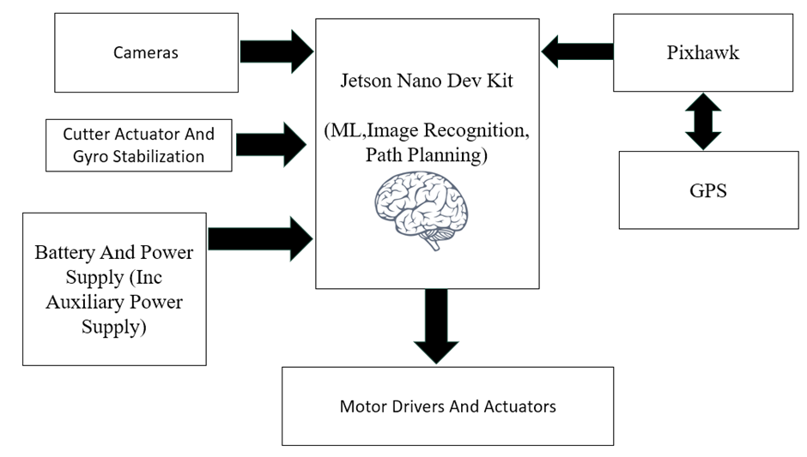

**Work Plan**

|  |  |  |  |  |  |  |  |  |  |  |
| --- | --- | --- | --- | --- | --- | --- | --- | --- | --- | --- |
|  | **Work Done in Months** | | | | | | | | | |
| Plans | **1-2** | **2-3** | **3-4** | **4-5** | **5-6** | **6-7** | **7-8** | **8-9** | **9-10** | **10-11** |
| Problem Identified |  |  |  |  |  |  |  |  |  |  |
| Literature Survey |  |  |  |  |  |  |  |  |  |  |
| Components Simulation |  |  |  |  |  |  |  |  |  |  |
| Site Visit |  |  |  |  |  |  |  |  |  |  |
| Data Set Collection |  |  |  |  |  |  |  |  |  |  |
| Image Recognition Training |  |  |  |  |  |  |  |  |  |  |
| CAD Design |  |  |  |  |  |  |  |  |  |  |
| Path Planning Testing |  |  |  |  |  |  |  |  |  |  |
| Assembling |  |  |  |  |  |  |  |  |  |  |
| Testing and Modifications |  |  |  |  |  |  |  |  |  |  |

1. **Application /importance in the socioeconomic context:**

The socio-economic context of introducing an autonomous tea harvesting system in Idukki, involves considering the impact on both the people and the economy of the region. Firstly, this technology aims to address challenges like labour shortages and high costs associated with traditional tea harvesting. By automating the process, it reduces the dependency on manual labour, potentially improving job opportunities for skilled workers in maintaining and operating these advanced systems. Economically, it can make tea production more efficient and cost-effective. Higher efficiency means better quality tea and increased production, contributing to the economic growth of the region. Additionally, the project fosters technological innovation, which can lead to new job opportunities and skill development, positively influencing the socio-economic fabric of Idukki. Overall, the implementation of autonomous tea harvesting aligns with the goal of achieving sustainable and prosperous tea plantations in the region.

1. Particulars of equipment required :

(Equipment only to govt/govt supported institutions. For Private self-financing Colleges, 50% of the actual Equipment cost subject to the maximum of sanctioned amount shall be borne by the college)

1. Particulars of any other facilities required:
2. Particulars of the facilities that will be provided by the institution where this project will be implemented:
3. Whether the scheme was submitted to any other organization for financial support, if so, the names of the institutions and their decisions may be indicated:
4. Budget Details: Estimated expenditure

|  |  |  |
| --- | --- | --- |
| Sl  No | Items | Amount (Rs) |
| 1 | Consumables - include the list of consumables which cost more than Rs. 1000/- **(Do not exceed 20% of the total amount)** | 66048/- |
| 2 | Equipment - Include the list of equipment (For Private self financing Colleges, 50% of the actual Equipment cost subject to the maximum of sanctioned amount shall be borne by the college) |  |
| 3 | Travel  **(Do not exceed 10% of the total amount)** | 2000/- |
| 4 | Contingency  **(Do not exceed 10% of the total amount)** | 3000/- |
|  | Total |  |

Signature of Principal Investigator:

Name, Address & Telephone No:

Place:

Date: Office Seal

|  |  |  |
| --- | --- | --- |
| Sl No | Items | Amount(Rs) |
| 1 | Jetson Nano Dev Kit 4GB | 20999 |
| 2 | PixHawk 2.4.8 | 10799 |
| 3 | Tea Harvester Mechanism | 14950 |
| 4 | 4* 24V 150W Motor | 9000 |
| 5 | Rugged Tyre 10’’ | 8000 |
| 6 | 4G Module | 2300 |
|  | Total | **66048/-** |